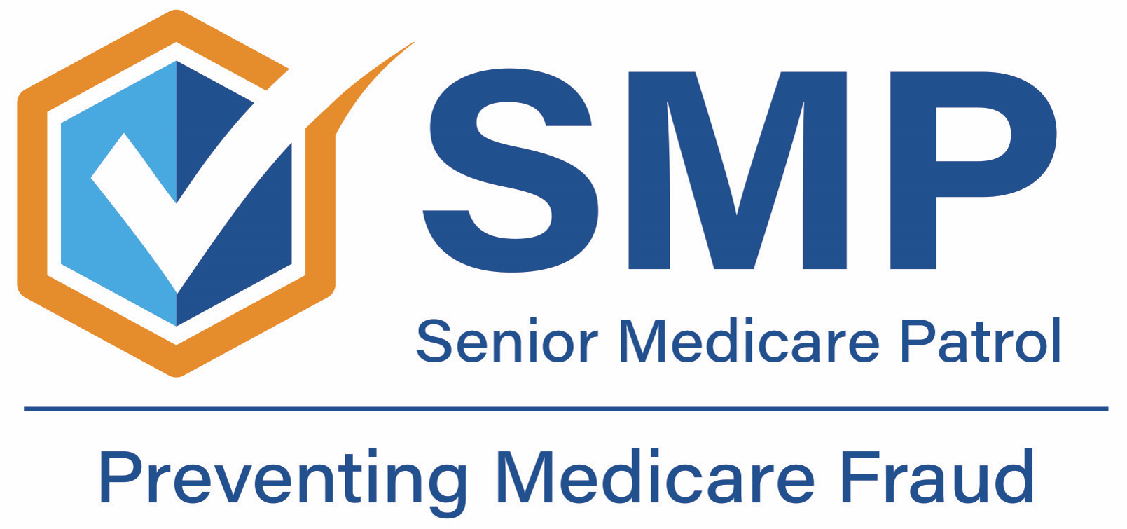

FOR IMMEDIATE RELEASE

Contact Information
[INSERT ORGANIZATION NAME. INCLUDE SENIOR MEDICARE PATROL.]
[INSERT CONTACT NAME]
[INSERT PHONE NUMBER]
[INSERT EMAIL ADDRESS]
[INSERT WEB ADDRESS]
Medicare Fraud Prevention Week Teaches Everyone How to Prevent Fraud
(City, State) – Fraud costs Medicare an estimated $60 billion per year. It costs Medicare beneficiaries in time, stress, their medical identities, and potentially their health. It costs families, friends, and caregivers in worry and lost work when helping their loved ones recover from falling victim to Medicare fraud.
“Medicare fraud has a devastating impact on both beneficiaries and the Medicare program,” said [INSERT SMP CONTACT NAME AND TITLE HERE. Be sure to also include “Senior Medicare Patrol (SMP)”]. “We teach people how to avoid experiencing Medicare fraud. By preventing fraud from happening, this program helps individuals and protects the Medicare program for generations to come.”
Learn how to protect yourself and your loved ones by joining the Senior Medicare Patrol (SMP) and their partners for Medicare Fraud Prevention Week which runs the week of June 5, or 6/5, because most people become eligible for Medicare when they turn 65.
“We’re excited to teach people both about how to protect themselves from Medicare fraud and about the services that the Senior Medicare Patrol program offers. We hope that people will remember the numbers ‘6-5’ to help us celebrate Medicare Fraud Prevention Week,” said [INSERT CONTACT NAME].
Everyone plays a part in the fight against fraud. During Medicare Fraud Prevention Week:
- Medicare beneficiaries can monitor their insurance statements to make sure products and services received match what is on the statements. They can request free My Health Care Trackers from their local SMP.
- Caregivers can help by being on the lookout for items such as durable medical equipment (like boxes of knee braces) lying around the house that may have been shipped to the beneficiary without their or their doctor’s approval. They can remind their client or loved one to never give out their Medicare number or other personal information over the phone.
- Families can help by talking to their loved ones about protecting their Medicare number just as they would a credit card number. They can help their loved ones create a Medicare.gov account to access their Medicare statements online or remind them to open and review them when they come in the mail. They can also register their phone number on “do not call” lists and go to optoutprescreen.com to opt out of mailings.
- Partners and professionals can help by sharing SMP information on social media, referring clients and consumers to the SMP, and inviting the SMP to speak during a shared event.
- Health care providers can help by talking to patients about health care-related scams such as those related to durable medical equipment and genetic testing schemes. They can remind them that products and services should only be ordered by physicians they regularly see. Needed medical items should never be ordered through TV ads or unsolicited calls.
- Community members can help by looking out for older neighbors. When in public, they can be aware of older individuals purchasing gift cards in large amounts. They can encourage those they know to talk to a trusted source about their Medicare questions and tell neighbors about the most recent Medicare scams. They can even consider volunteering with the local SMP!
The Senior Medicare Patrol (SMP) is ready to provide you with the information you need to PROTECT yourself from Medicare fraud, errors, and abuse; DETECT potential fraud, errors, and abuse; and REPORT your concerns. SMPs help educate and empower Medicare beneficiaries in the fight against health care fraud. Your SMP can help you with your questions, concerns, or complaints about potential fraud and abuse issues. It also provides information and educational presentations.

